Tode Hardware
General Development

Equipment, Tools, Supplies, Procedure and Settings

by TGit-Tech [ http://www.tgit-tech.com ]
Build Version: 212M / Last Updated: 2021-11-06

Table of Contents
1. Introduction 2
2. Workstation $770 3
2.1 Equipment $530 3
2.2 Tools $120 3
2.3 General Supplies $120 3
2.4 CNC Routing a PCB ( Settings & Process ) 4

Introduction

The Tode System ( Dimmed ones are still a work in progress. Not Available Yet. )

- Tode-RC = Handheld Remote Control Models
  - Model #AMP Arduino Mega Pro (No RF Module)
  - Model #AMPE32T30 Arduino Mega Pro + Ebyte E32-433T30D (1W/30dbm) RF module
  - Model #AMPE32T20 Arduino Mega Pro + Ebyte E32-433T20D (250mW/20dbm) RF module
  - Model #AMPXBEE Arduino Mega Pro + Digi XBee RF Module

- Tode-SideIO = Input/Output Stations
  - Model #TSIOST Tode SideIO with Screw Terminals
  - Model #TSIOAP Tode SideIO with Aviation Plugs

Manuals
- User Manual Operator Instructions including Setup and Wiring
- Hardware Development How to build the hardware including detailed circuit diagrams
- Firmware Development How to adjust and create firmware for the Tode

The Tode System is liscensed under the MIT Liscense. It's hosted on Github.com at:
https://github.com/TGit-Tech/Tode-RC

Workstation $780

Equipment $530
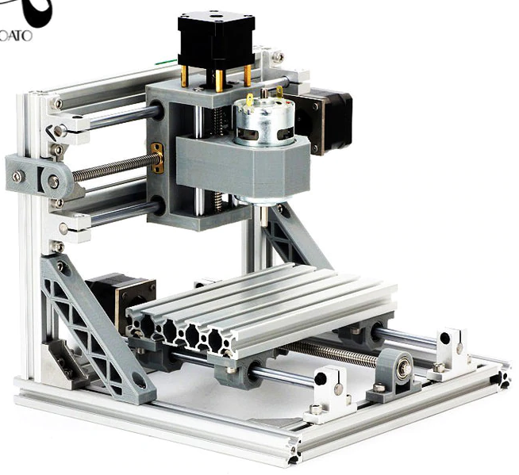  - CNC Mill ( ~ $150 )  - DIY CNC1610  - Equipped with End-Stops and Board-Level Clips  - 3.175mm Shank Size | 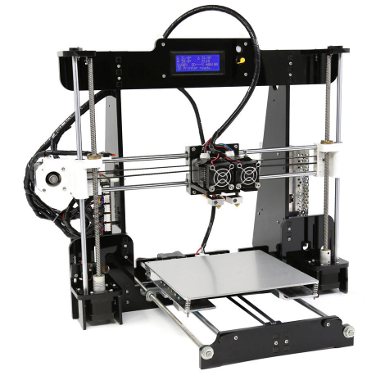  - 3D Printer ( ~ $150 )  - Anet A8  Various 3D Printers will work.
- Reflow Oven T-962 ( ~ $230)
  - Infrared IC Heater
  - 800W

Tools $130
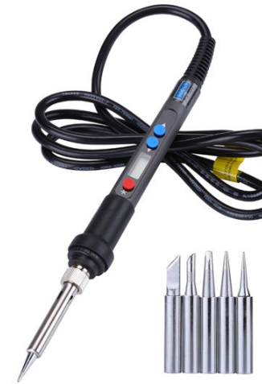 |  |  | 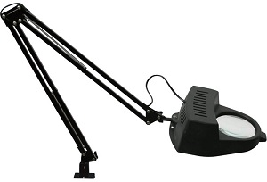
Solder Iron  With Tiny Tips  Price $40 | Dikes / Cutters  Price: $10 | Wire Strippers  Price $12 | Manification  Price $40
Tweezers Kit  Price: $10 | 3.5mm Drill Bit  10Pcs Price $10

General Supplies $120
CNC Pyramid Bits  0.2mm Tip 45-deg  3.175mm shank  Price $10/10pcs | V-Shape CNC Bits  0.2mmTip 10-deg  Price: $10.00/10pcs | CNC Drill Bits  0.1 to 1.0mm  1.0 to 3.0mm  Price$20.00/20pc | Liquid Tin  Price $20
0.031” 60/40  Rosin-Core Solder  Price $8.00 | Lead Solder Paste  Price $16.00 | No-Clean  Price: $4.00 | Solder Wick  Price $3.50
22 AWG Stranded Colored Wire
Price $20/6-rolls

Software
  https://www.kicad.org/ |   http://flatcam.org/ | bCNC Sender  https://github.com/vlachoudis/bCNC

CNC Routing a PCB ( Settings & Process )

Printed Circuit Boards can be either ordered from a Custom PCB Manufacturer or created with a CNC Router.

- Custom Manufactured PCB
  - Benefits - Custom PCB manufacturing is by far the better approach.
    - Copper through holes provide better connection
    - A Silk Sscreen for better corrosion resistance
    - Far easier to solder

  - Common Custom Manufacturing Businesses
    - https://oshpark.com/
    - https://jlcpcb.com/
    - https://www.pcbway.com/orderonline.aspx
    - https://www.customcircuitboards.com/
    - https://custompcb.com/

- CNC Routed PCB
  - Benefits
    - Generally cheaper by a couple dollars
    - Instant product (No shipping/manufacturing wait time)
    - Good for designing phases; not good for finished design production.

- Using the CNC machine shown in Workstation::Equipment
- Using the 3D Printed 3” x 4” Cu-Clad PCB Holder
- Using Isolation Bit 45-deg, 0.2mm tip, Diamond Shape
- Using Flatcam Settings
  - Cut Z: -0.05 mm
  - Travel Z: 1.0 mm
  - Feed Rate: 45.0 mm/s
  - Tool Dia: 0.199 mm
  - Spindle Speed: 2000
  - Multi-Depth: Un-Checked
  - Depth/Pass: N/A
- Using bCNC
- Load PCB onto CNC1610 using PCB holder
- Load the Trace Isolation Bit ( Suggest 45-deg 0.2mm Tip Diamond Shape )
- Open bCNC
- Home the CNC
- Zero Coordinates (Under [Control] Press the 'XYZ=0' button)
- Command G01 X40Y17 F300 (Enter Command at bottom-left press Enter)
- Zero Coordinates (Under [Control] Press the 'XYZ=0' button)
- Manually move bit close but not touching PCB (Under [Control] bottom-left “Control” Section)
- Zero Z Coordinate
- Hook-up Probing Wire to Bit
- Probe for Board-Level Z=0
  - Settings → Fast Probe @100, Probe Feed @ 5
  - Push 'Probe' ribbon button, then under 'Probe' Section click 'Probe' button under 'Goto'.
- Once the Probe stops and machine goes to 'Idle' Press Z=0.
- Open File
- Set Autolevel margins (Usually ~10x10 Steps)
- Scan for Autolevel (Press Ribbon-Bar 'Scan' Button)
- Probe again and Autolevel Zero
- Remove Autolevel Probe Wire
- Start Isolation Routing
- Preform Isolation Routing
- Preform Hole Drilling
- Preform Edge-Cuts
- Sand & Treat with Liquid Tin

